Text :

Innovation is the practical implementation of ideas that result in the introduction of new goods or services or improvement in offering goods or services.
ISO TC 279 in the standard ISO 56000:2020 defines innovation as "a new or changed entity, realizing or redistributing value".
Others have different definitions; a common element in the definitions is a focus on newness, improvement, and spread of ideas or technologies.
Innovation often takes place through the development of more-effective products, processes, services, technologies, art works or business models that innovators make available to markets, governments and society.
Innovation is related to, but not the same as, invention: innovation is more apt to involve the practical implementation of an invention (i.e. new / improved ability) to make a meaningful impact in a market or society.
Not all innovations require a new invention.
Technical innovation often manifests itself via the engineering process when the problem being solved is of a technical or scientific nature. The opposite of innovation is exnovation.

Run 1 Summary :

📘 AI Summary:
Innovation is the practical implementation of ideas that result in the introduction of new goods or services. Not all innovations require a new invention. Technical innovation often manifests itself via the engineering process. The opposite of innovation is exnovation.

Run 2 Summary :

📘 AI Summary:
Innovation is the practical implementation of ideas that result in the introduction of new goods or services. Not all innovations require a new invention. Technical innovation often manifests itself via the engineering process. The opposite of innovation is exnovation.

Run 3 Summary :

📘 AI Summary:
Innovation is the practical implementation of ideas that result in the introduction of new goods or services. Not all innovations require a new invention. Technical innovation often manifests itself via the engineering process. The opposite of innovation is exnovation.

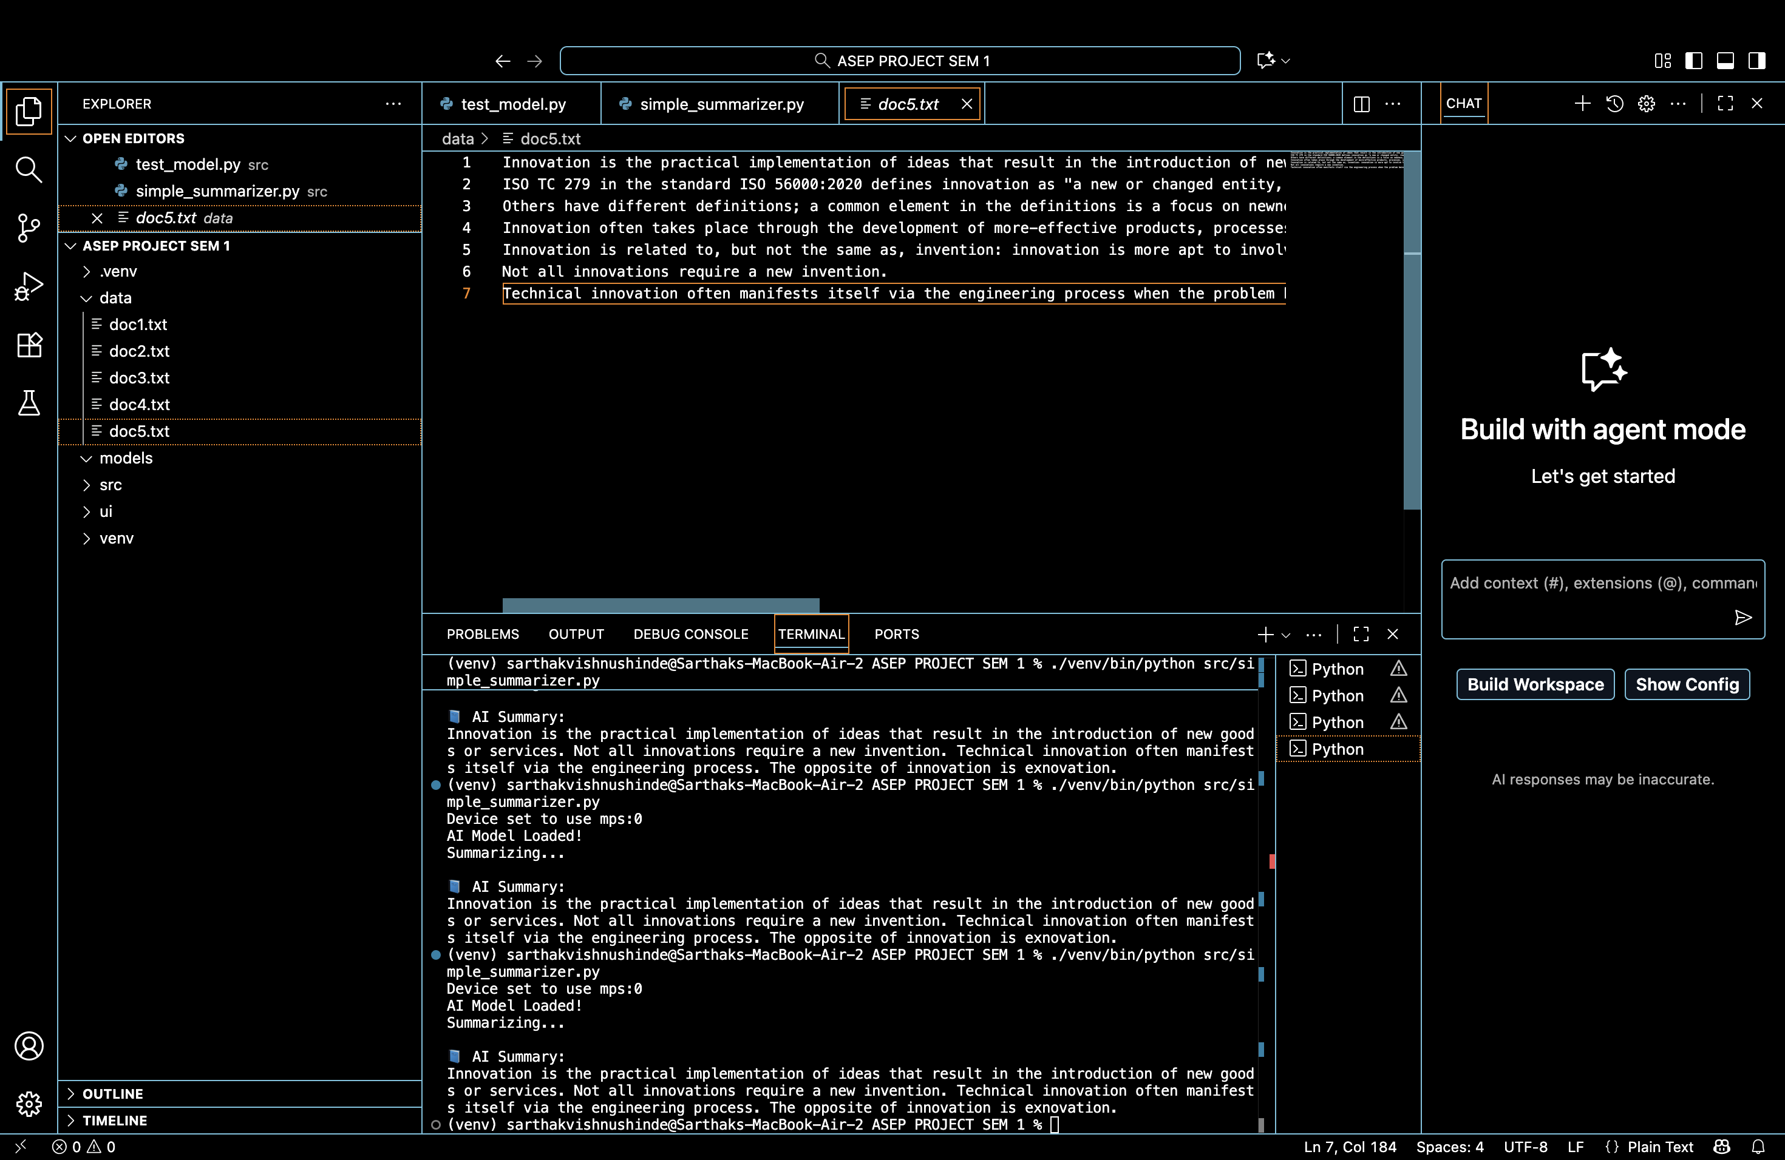
Screenshot Of the Code :

